## FreeRTOS Notes

This is the architechture of the source code. The architecture of the Hardware abstraction is located within the folder Portable/Platform.

(Electronics)

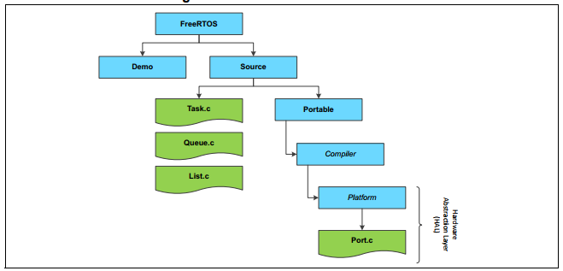

There is an API which controls the FreeRTOS abstraction.

An API (Application Programming Interface) is a set of functions that allow access the features or data of an operative system, service or an application.

Interesting APIs are: vTaskStart/EndScheduler, vTaskSuspend/ResumeAll, xQueueSendFromISR, xQueueCreate, xSemaphoreCreateMutex.

## The abstraction within the STM32 Family of microcontrollers

This is a description

# Theory of software for embedded systems

Round Robin Scheduling

The following table will illustrate how the Round-Robin Scheduling works with a queue of tasks. Important to notice is that the Time Slices (time-quanta) are not fixed time slots but only a maximal value of time that a task can be executed by the processor. If a task takes longer to be finished the preemptive scheduler will stop it and reschedule it after all the other tasks have received their correspondent processing time.

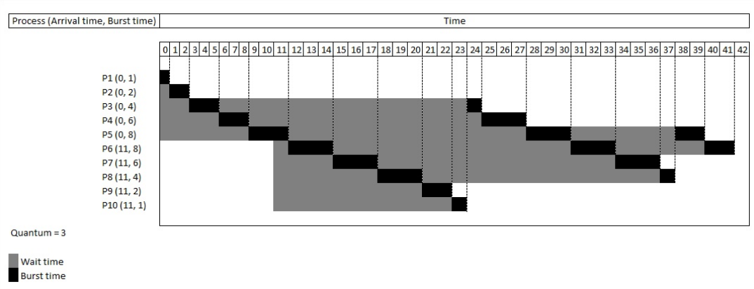

There can be seen how the tasks are stopped after the time quantum is finished for the current task and it is continued until the queue is finished.

The following is another example showing the changes in the task queue.

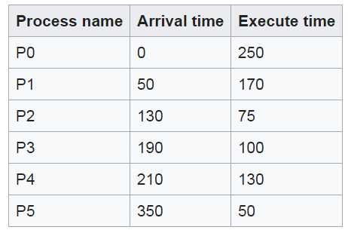

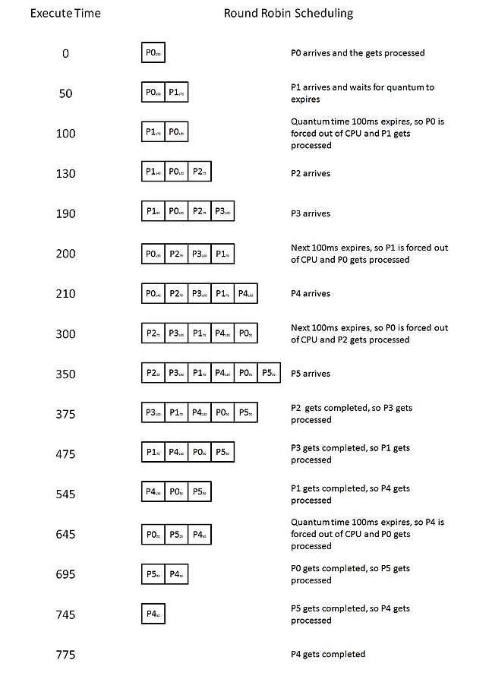

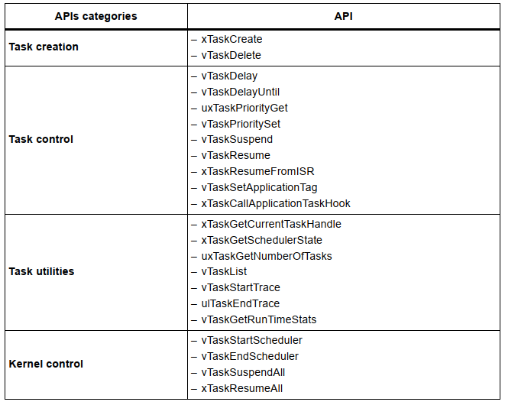

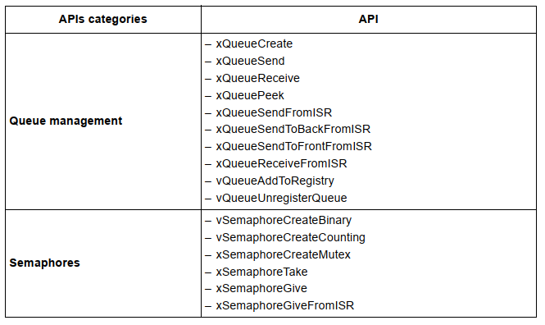

NOTES regarding the design of the embedded system

The Scheduler within the FreeRTOS switches between threads not tasks.